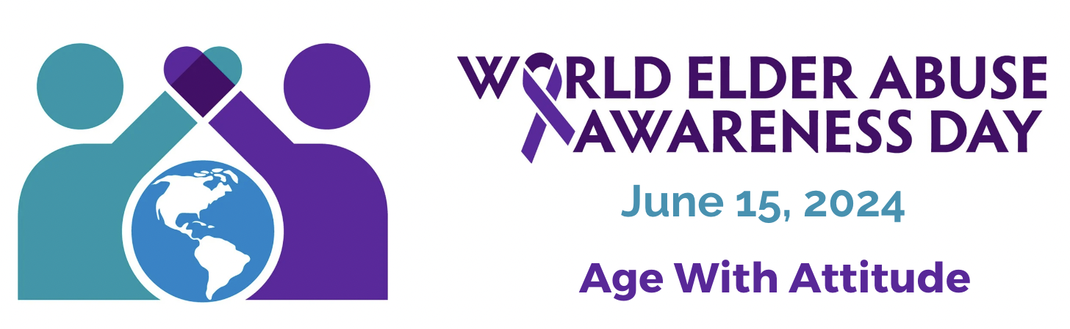

Location, [Date]

[insert name of organization/Elder Abuse Network] stands up for the Rights of Older Adults

on World Elder Abuse Awareness Day (WEAAD) june 15th, 2024

Local effort to raise awareness about Elder Abuse and Neglect in our community.

[Date/City], ON - [Insert Agency /Network Name] marks WEAAD 2024 by hosting [insert event type and name/details]. This year’s theme is “Age With Attitude”. Join in the conversation as together, we spread the word about the Rights of older adults - their rights to safety, dignity, and respect in Ontario.

On [date] at [time] the [Network/Agency Name] will be hosting a [event information] to create awareness of Elder Abuse and engage community members to promote dignity and respect of older adults.

WEAAD serves as a Call-to-Action for individuals, organizations, and communities to raise awareness. [Name] joins the global movement to unite communities in raising awareness about elder abuse and the impact it has on the quality of life of our most vulnerable citizens.
The basic Human Rights of older adults are challenged and undercut each and every day - tragically, this has never been more true than over this past year, during the COVID-19 pandemic.

Every year an estimated 200,000, or 10% of seniors living in Ontario are victims of elder abuse and neglect. It’s estimated that 1 in 6 seniors in the world are victims. But that is only part of the stark truth: Experts believe that elder abuse is not only significantly under-reported, it remains a hidden crime, in part because so many of our communities lack the social supports to allow those suffering and experiencing abuse to from reporting it. We, as a community, cannot allow this to continue.

The [name] is developing programs to educate families and professionals who work with older adults, to better understand the importance of preventing isolation, knowing how to spot the warning signs of abuse, and what to do to address various situations of abuse or neglect. By doing all that we can to strengthen the social support structures, we can reduce social isolation, protect communities and families against elder abuse.

“This local WEAAD event will heighten awareness, that elder abuse is a serious that must be addressed. We all have a vital role to play in creating a peaceful, supportive and just society” stated [name of agency/network spokesperson]. We invite and encourage you to join us on [Date] in our efforts to create those important conversations around elder abuse prevention and what you can do to uphold and protect the rights of seniors in our community.

-30-
If you would like more information about this event, please contact:

Contact [Contact Name]
Telephone [Agency Phone] /Cell [Cell Phone]
Email [Agency E-mail]
Website [Website]

