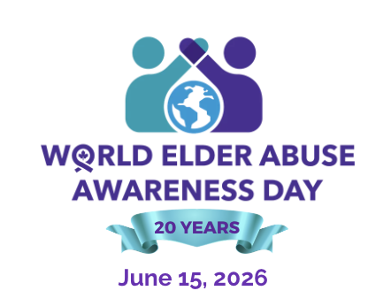

PROCLAMATION
WORLD ELDER ABUSE AWARENESS DAY
June 15, 2026

WHEREAS: (Insert City, Town, Community)'s older adults deserve to be treated with respect and dignity and valued as contributing members of society, imparting a wealth of experience and wisdom in our communities, and
WHEREAS: The International Network for the Prevention of Elder Abuse, in support of the United Nations International Plan of Action, proclaimed this day to recognize the significance of elder abuse as a public health and human rights issue; and
WHEREAS: The (Insert City, Town, Community) recognizes the importance of taking action to invest in
creating social change, to prioritize the prevention of elder abuse and raise awareness to foster a better understanding of abuse and neglect of older adults and their rights; and

WHEREAS: Elder abuse has a significant impact on the lives of older adults and families; and is not limited to race, gender, culture, or circumstance, and regardless of whether the abuse is physical, emotional, sexual, financial or neglect; and
WHEREAS: Ageism and social isolation are major causes of elder abuse in Ontario; and
WHEREAS: Recognizing that it is up to all of us, as citizens, organizations, communities, and governments, to work collectively to prevent violence and abuse of older adults in their homes and communities; and
WHEREAS: Preventing abuse of older adults through improving and maintaining social and health services and systems such as housing, income security, and safety will improve their quality of life and allow them to live independently and contribute to the vibrancy of Ontario; and
WHEREAS: Where there is respect for human rights, equality, and justice there can be no abuse; therefore, all (Insert City, Town, Community) residents are urged to join this global movement to promote the Rights of Older Adults and Stop Abuse and Restore Respect.

THEREFORE; I, ______________________Mayor of (Insert City, Town, Community), Ontario do hereby
proclaim June 15, 2026, as World Elder Abuse Awareness Day and encourage all residents to recognize and celebrate seniors and their ongoing contributions to the success and vitality of our province.

Dated on this day of ____________, 2026. __________________________
Signature

